**IPC-NEXUS FLOW:**

"Need to understand the legal implications of a crime? Our web application provides instant access to relevant Indian Penal Code (IPC) sections and punishments. Simply describe the incident or provide keywords, and our NLP-powered system will deliver precise legal information. Built with a modern React interface and a powerful Flask backend, the application also allows for secure complaint registration and retrieval using a MongoDB cloud database. Empowering users with legal clarity, this tool simplifies complex legal terminology and provides essential information at your fingertips."

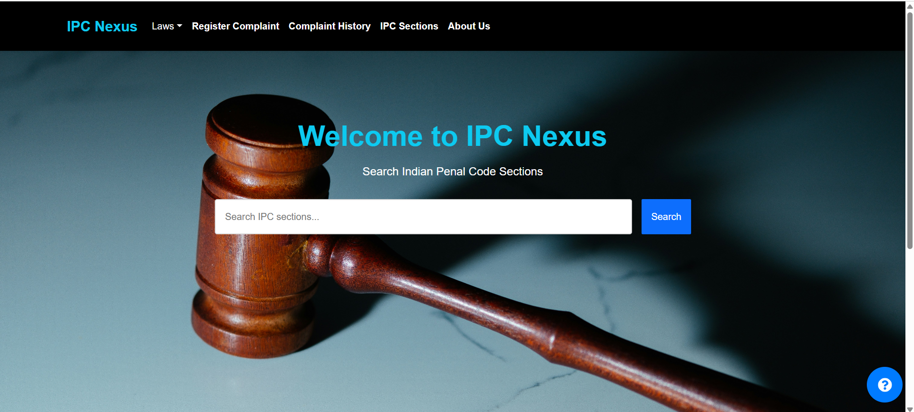

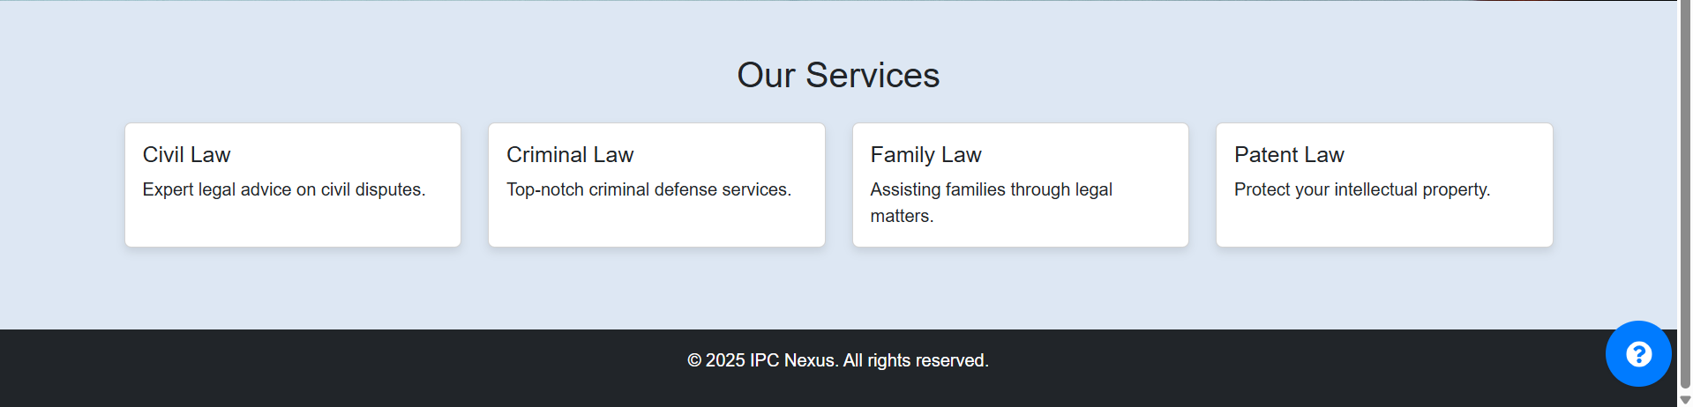

The user can directly search in the search bar, for the specific crime:

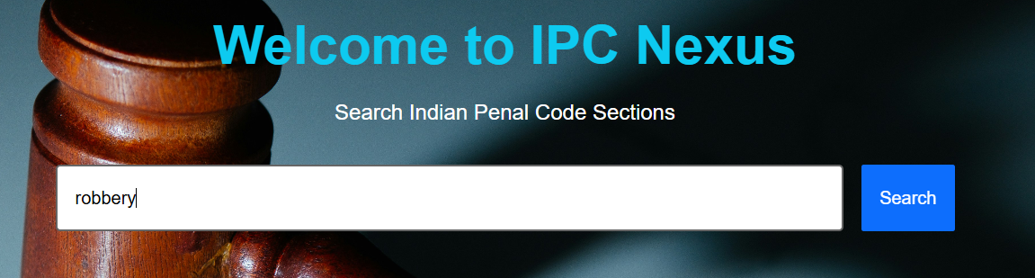

And it would return all possible Indian Penal code Sections with punishment and fine for that crime:

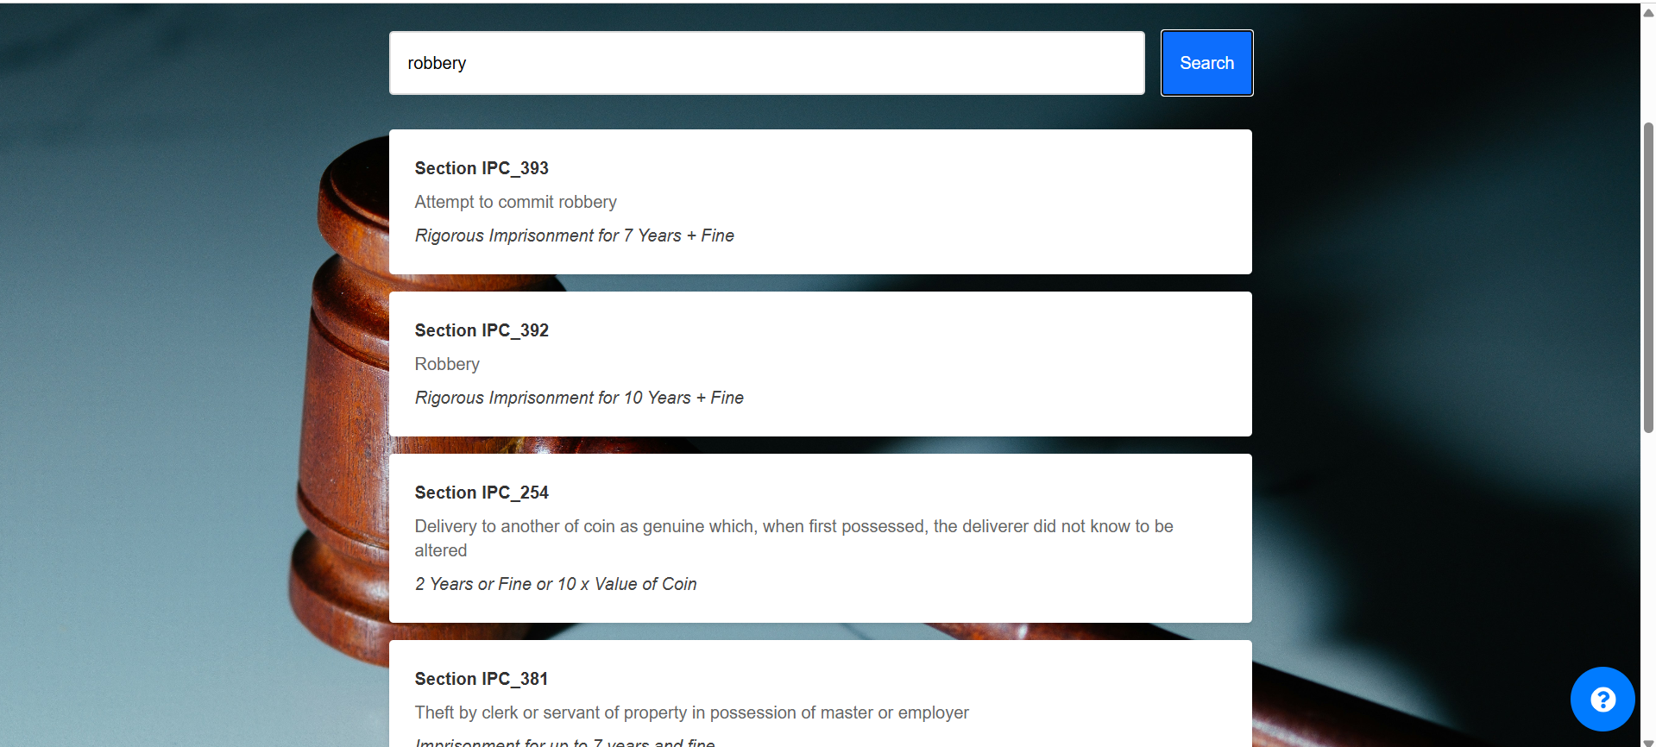

So when user clicks enter or click on search icon all the related results are returned.

After this we can go to second tab to study about various laws in detail:

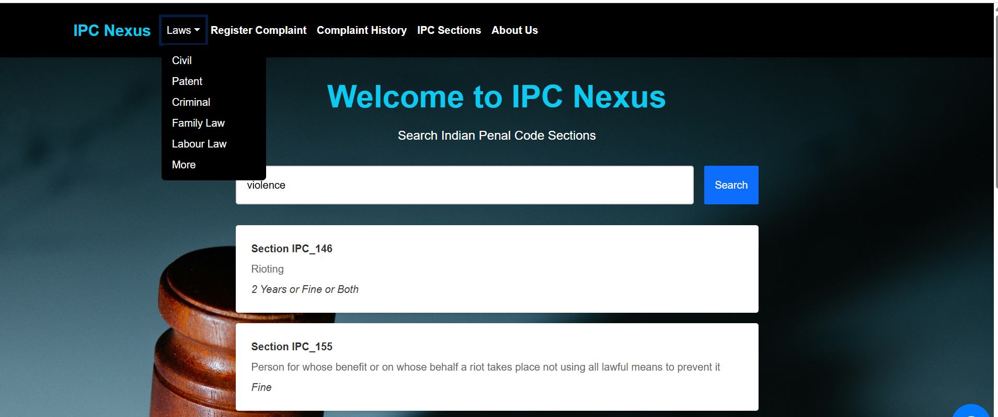

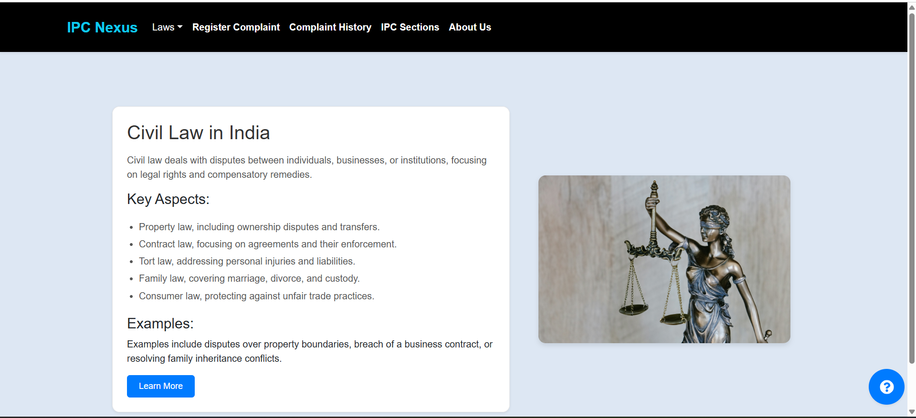

The next tab that we have is the register complaint tab that returns the FRI form in digital format for entering the incident:



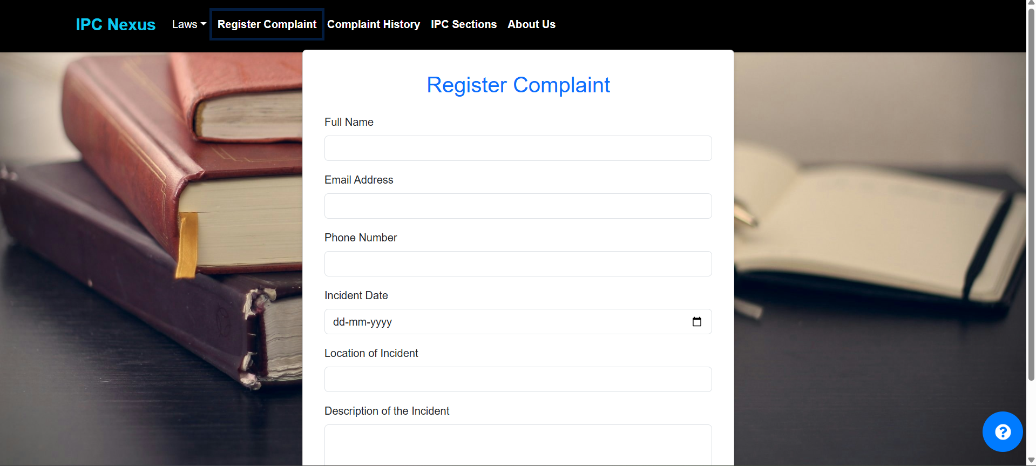



And when a user submit a complaint we can verify it from:

Complaint history tab:

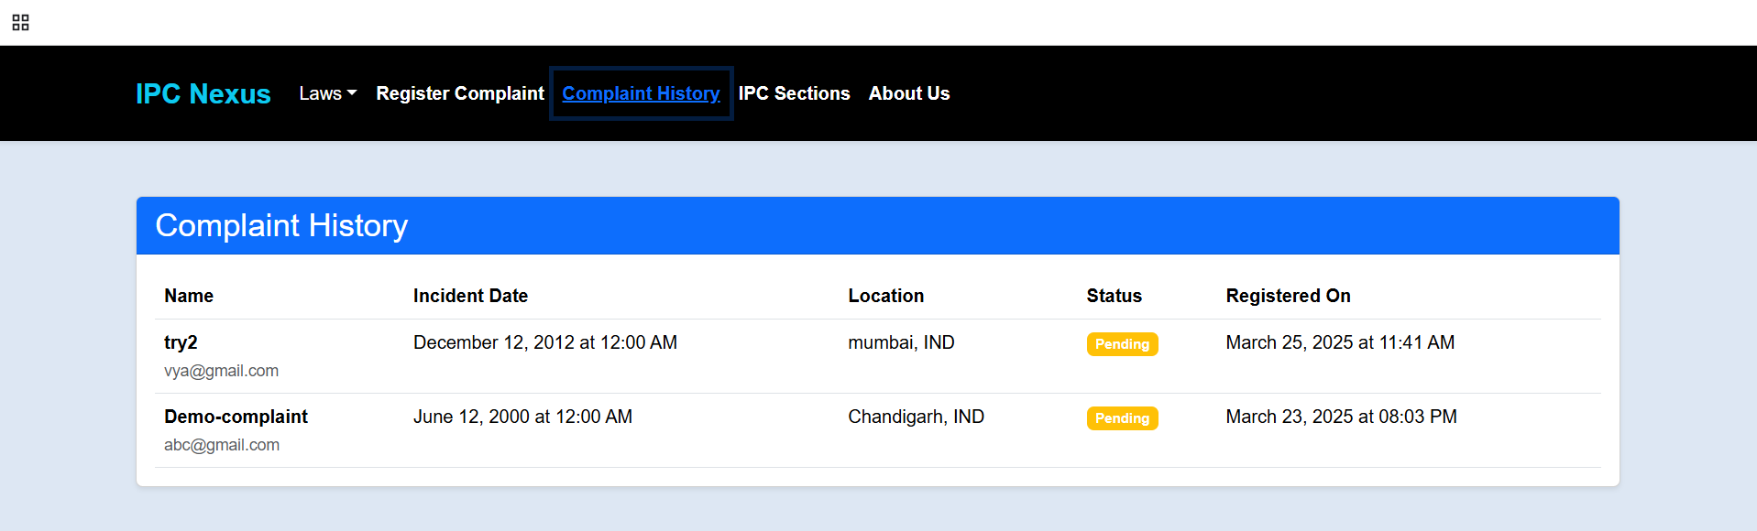

Then we have an ipc section tab which returns data related to ipc section offense and lastly punishment…  
here a person can specifically search for specific “sections”.

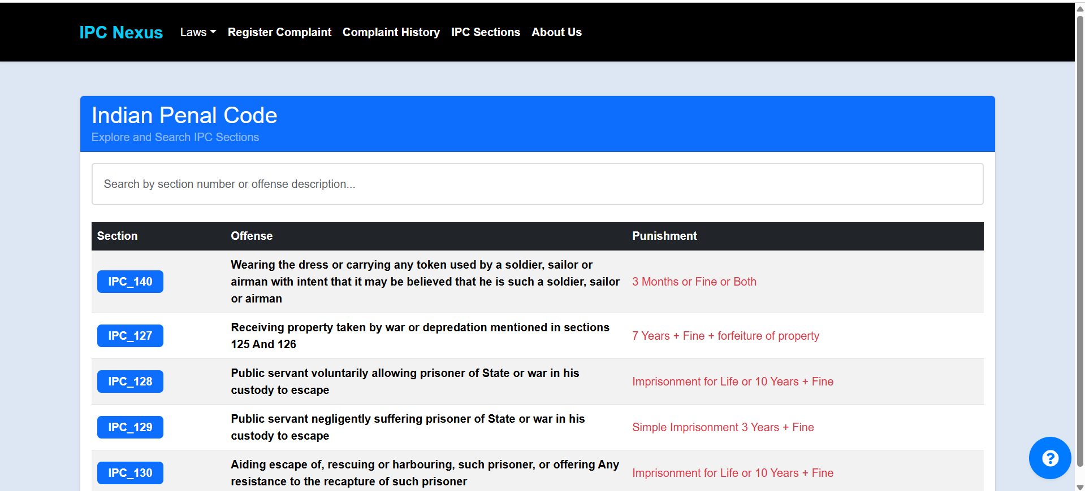

As in below example I just typed 45, so it returning all ipc sections starting with 45 in it:

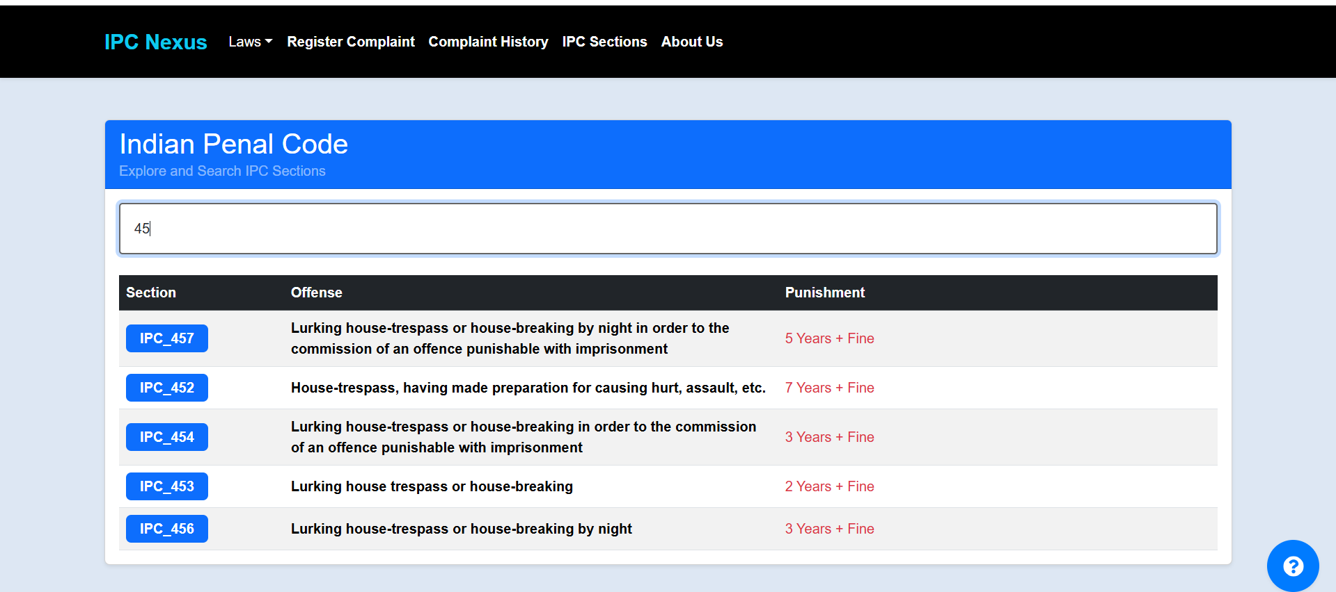

Then in last tab we have about us page, describing our mission:

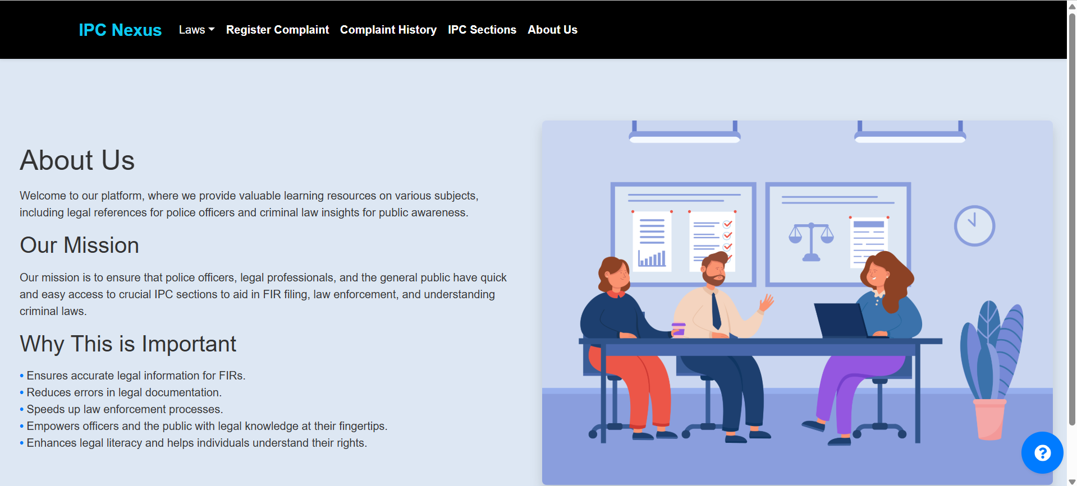

Then we also have created bot to guide through our website:

you can click on the blue icon on the bottom right to access it and if u have some extra question then u can submit it from there as well:

